**Coding Challenge**

**Problem Statement:**

Create SQL Schema from the application, use the class attributes for table column names.

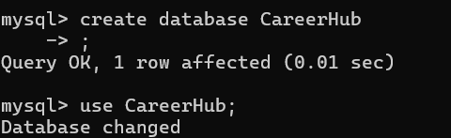

**Table: Companies**

Attributes:

• CompanyID (Primary Key, int): Unique identifier for each company.

• CompanyName (string): The name of the hiring company.

• Location (string): The location of the company.

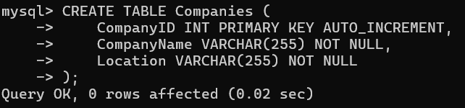

**Table: Jobs**

Attributes:

• JobID (Primary Key, int): Unique identifier for each job listing.

• CompanyID (Foreign Key, int): References the CompanyID of the hiring company.

• JobTitle (string): The title of the job.

• JobDescription (text): A detailed description of the job.

• JobLocation (string): The location where the job is based.

• Salary (decimal): The salary offered for the job.

• JobType (string): Type of job (e.g., Full-time, Part-time, Contract).

• PostedDate (datetime): Date and time when the job was posted.

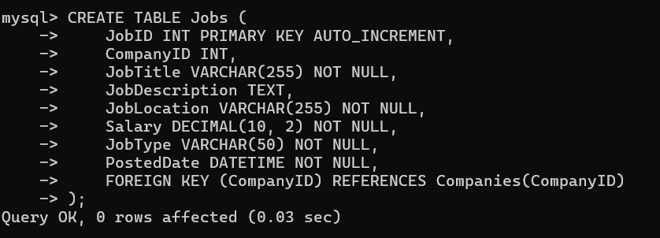

**Table: Applicants**

Attributes:

ApplicantID (Primary Key, int): Unique identifier for each applicant.

• FirstName (string): The first name of the applicant.

• LastName (string): The last name of the applicant.

• Email (string): The email address of the applicant.

• Phone (string): The phone number of the applicant.

• Resume (text): The applicant's resume or CV (text or file reference).

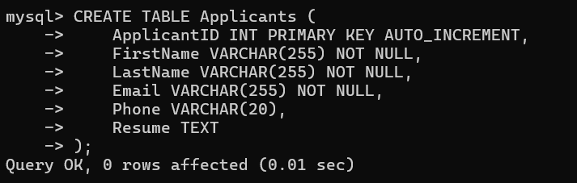

**Table: Applications**

Attributes:

• ApplicationID (Primary Key, int): Unique identifier for each job application.

• JobID (Foreign Key, int): References the JobID of the job listing.

• ApplicantID (Foreign Key, int): References the ApplicantID of the applicant.

• ApplicationDate (datetime): Date and time when the application was submitted.

• CoverLetter (text): The applicant's cover letter for the specific job.

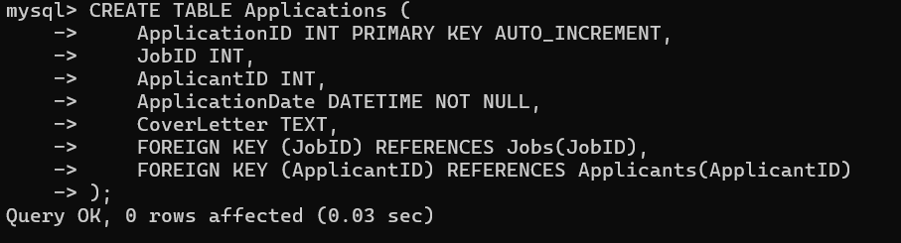

**Note : To ensure that tables do not exist already we can add “ IF NOT EXISTS “ between CREATE TABLE and table_name for each query for creating tables.**

**Eg.**

**CREATE TABLE IF NOT EXISTS Companies (**

**CompanyID INT PRIMARY KEY AUTO_INCREMENT,**

**CompanyName VARCHAR(255) NOT NULL,**

**Location VARCHAR(255) NOT NULL**

**);**

**Filling data into tables:**

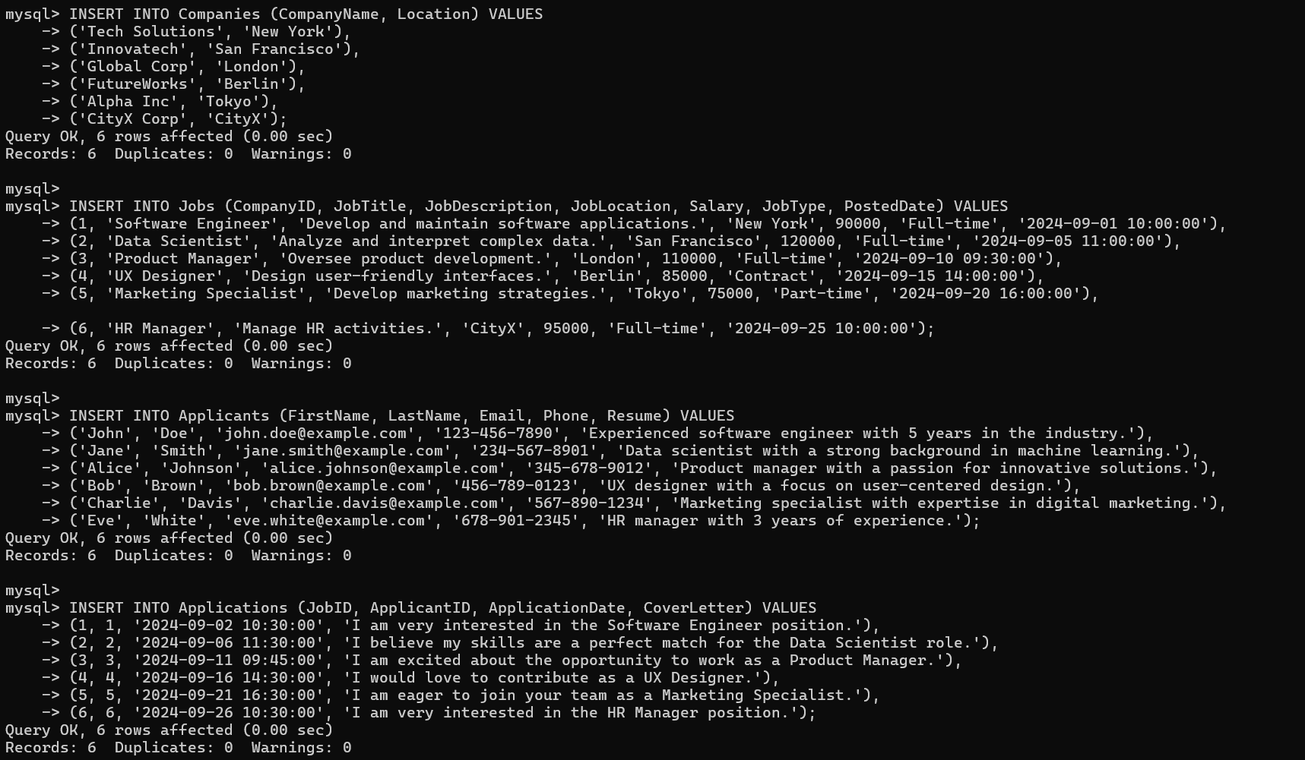

**Queries:**

**5. Count the Number of Applications Received for Each Job Listing**

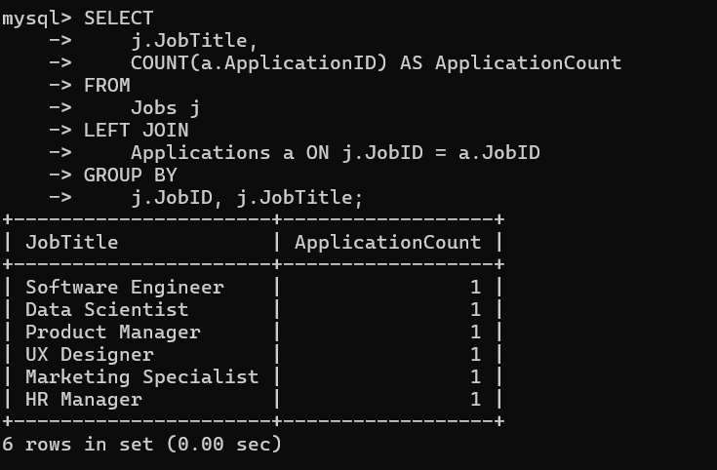

**Description:** This query counts the number of applications received for each job listing by joining the Jobs and Applications tables and grouping by job titles.

**6. Retrieve Job Listings within the Calculated Salary Range**

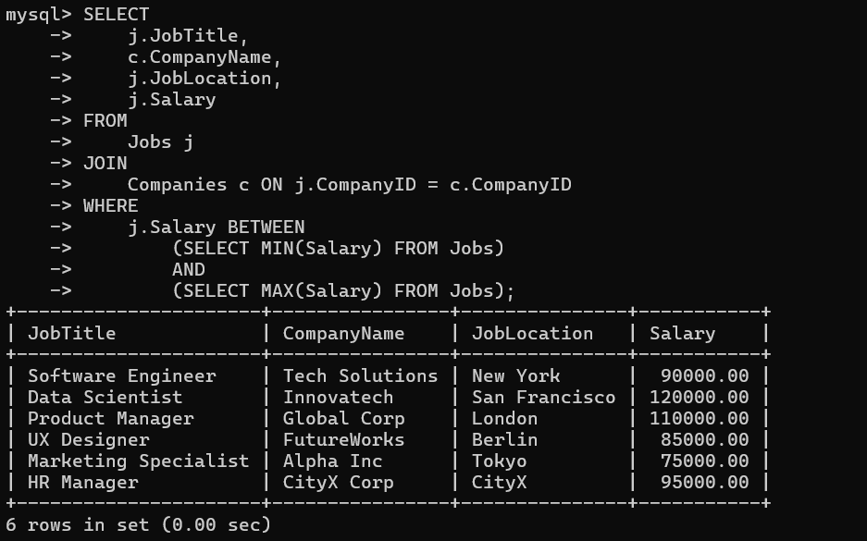

**Description:** This query retrieves job listings with salaries within the calculated range of minimum and maximum salaries.

**7. Retrieve Job Application History for a Specific Applicant**

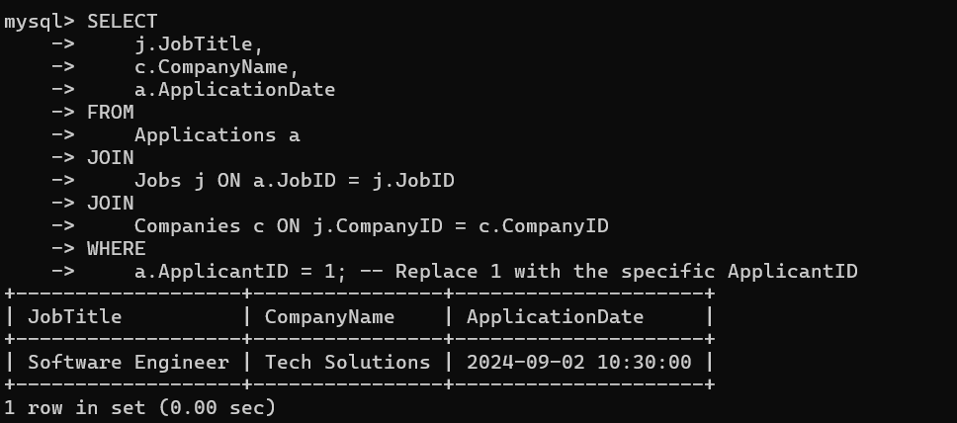

**Description:** This query retrieves the job application history for a specific applicant by joining the Applications, Jobs, and Companies tables.

8. **Calculate and Display the Average Salary Offered by All Companies**

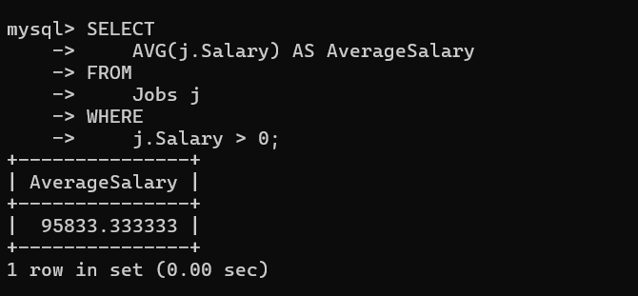

**Description:** This query calculates and displays the average salary offered by all companies.

9. **Identify the Company that has Posted the Most Job Listings**

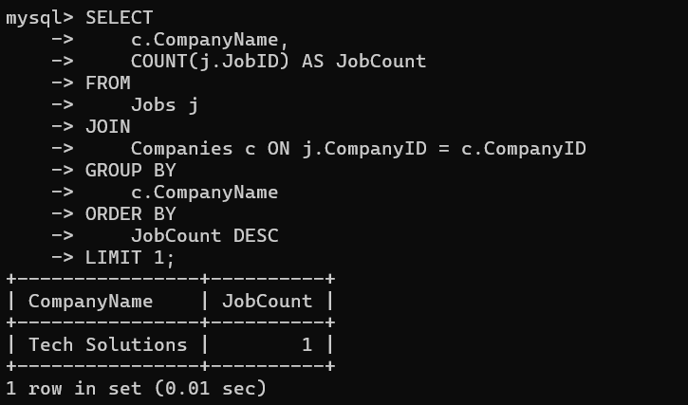

**Description:** This query identifies the company that has posted the most job listings by counting the number of jobs posted by each company.

**10. Find Applicants Who Have Applied for Positions in Companies Located in ‘CityX’**

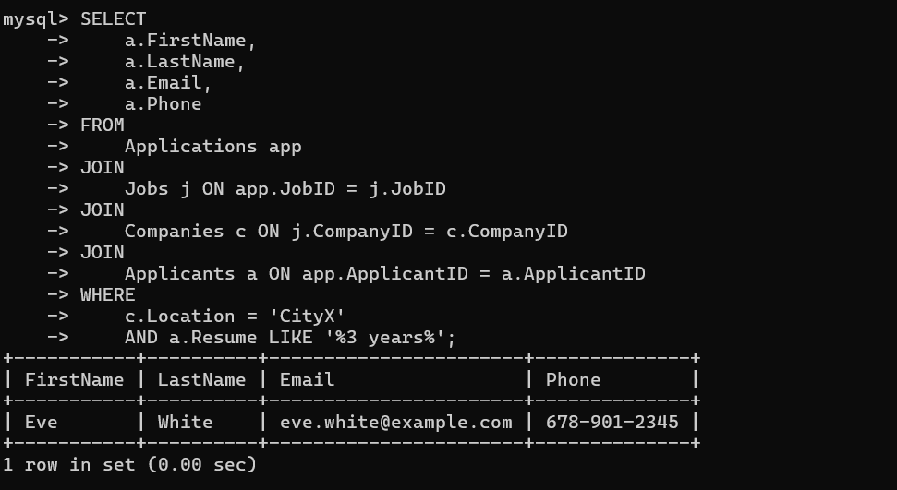

**Description:** This query finds applicants who have applied for positions in companies located in ‘CityX’.

11. **Retrieve a List of Distinct Job Titles with Salaries Between $60,000 and $80,000**

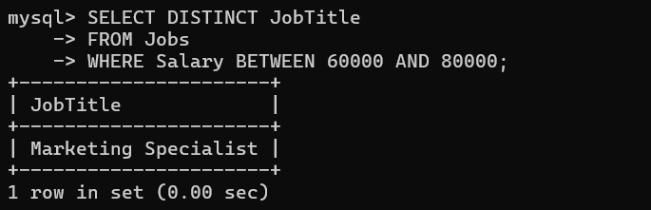

**Description:** This query retrieves a list of distinct job titles with salaries between $60,000 and $80,000.

**12. Find the Jobs That Have Not Received Any Applications**



**Description:** This query finds the jobs that have not received any applications by performing a left join between Jobs and Applications and checking for null values in the Applications table.

**13. Retrieve a List of Job Applicants Along with the Companies They Have Applied To and the Positions They Have Applied For**

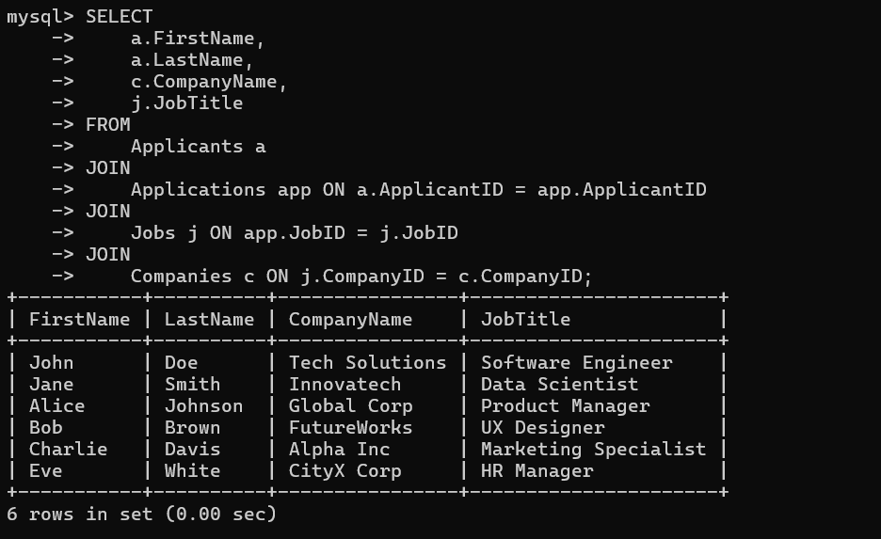

**Description:** This query retrieves a list of job applicants along with the companies they have applied to and the positions they have applied for.

14. **Retrieve a List of Companies Along with the Count of Jobs They Have Posted, Even If They Have Not Received Any Applications**

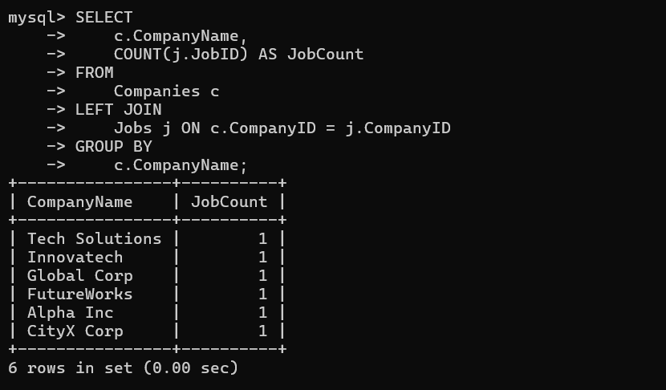

**Description:** This query retrieves a list of companies along with the count of jobs they have posted, even if they have not received any applications.

**15. List All Applicants Along with the Companies and Positions They Have Applied For, Including Those Who Have Not Applied**

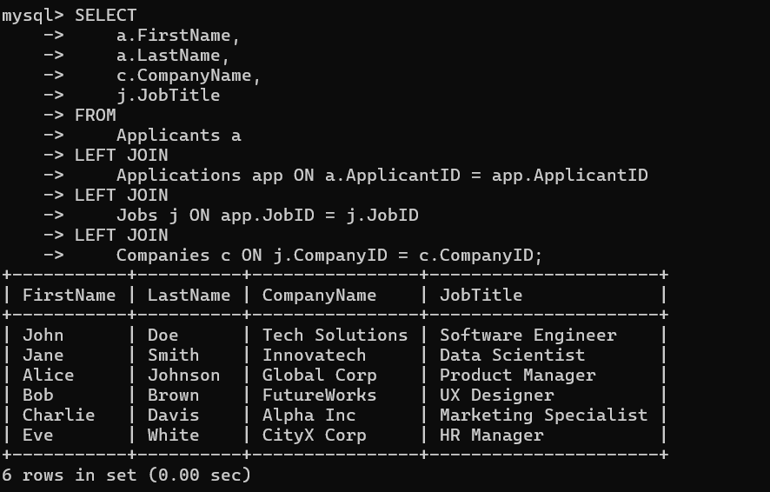

**Description:** This query lists all applicants along with the companies and positions they have applied for, including those who have not applied.

**16. Find Companies That Have Posted Jobs with a Salary Higher Than the Average Salary of All Jobs**

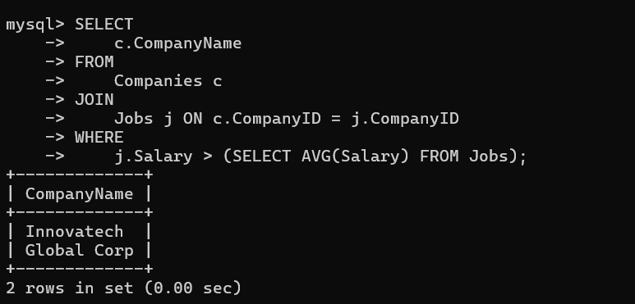

**Description:** This query finds companies that have posted jobs with a salary higher than the average salary of all jobs.

**18. Retrieve a List of Jobs with Titles Containing Either ‘Developer’ or ‘Engineer’**

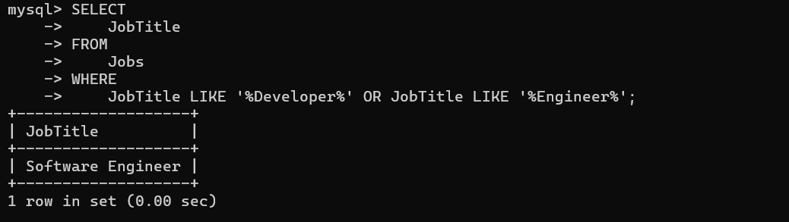

**Description:** This query retrieves a list of jobs with titles containing either ‘Developer’ or ‘Engineer’.

**19. Retrieve a List of Applicants and the Jobs They Have Applied For, Including Those Who Have Not Applied and Jobs Without Applicants**

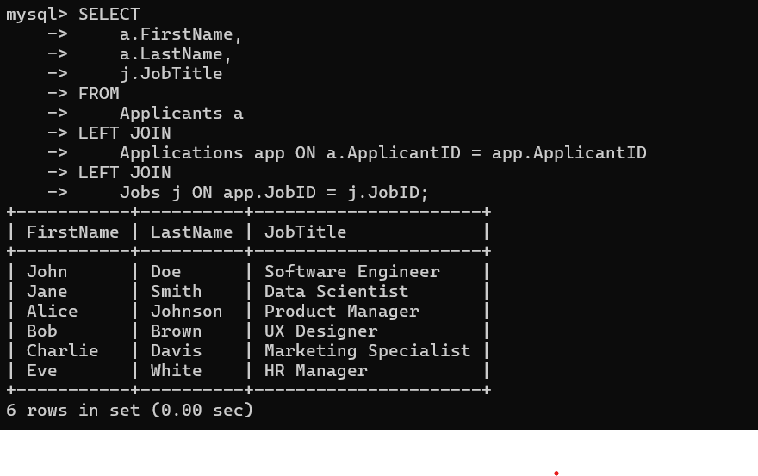

**Description: This query retrieves a list of applicants and the jobs they have applied for, including those who have not applied and jobs without applicants.**

**20. List All Combinations of Applicants and Companies Where the Company Is in a Specific City and the Applicant Has More Than 2 Years of Experience**

